FF-8010 Display
FF-800 Status Display Module
Installation Manual

Document Rev- : June 12, 2016

Table of Contents

1. Warranty 1
2. Contact Address 1
3. Reference Documents 1
4. INTRODUCTION 2
5. OPERATION OVERVIEW 2
6. INSTALLATION 2

Warranty
FF Systems warrants its products to be free from defects for one year from the date of shipment. FF Systems may opt to repair or replace (at our option) any defective product. FF Systems does not warrant any defect due to lightning or other natural disaster. Any user modifications or repairs to any product sold by FF Systems will void this warranty. All returns must be accompanied by a Return Material Authorization (RMA) number provided by FF Systems prior to shipment. Shipments that do not have the proper return authorization prominently noted on the outside of the package will not be accepted. The purchaser is responsible for all shipping charges for any service procedure(s) performed by FF Systems (including warranty service).

Contact Address

FF Systems
www.ke0ff.org
joeh@ke0ff.org

Reference Documents

The following documents are referenced in this installation manual. They may be obtained from the adjacent web link, or contact Joe Haas at the address indicated above.

FF-800 Repeater Controller Installation and Operation Manual

FF-800 Technical Manual

INTRODUCTION

The FF-8010 is a multi-LED interface module designed for the FF-800 repeater controller. This module presents real-time status of the FF-800. It uses a serial interface to transfer the LED data and also features a microphone pre-amp and 8-pin circular microphone connector to allow a Kenwood or ICOM microphone to be used as a local audio or command input to the FF-800.

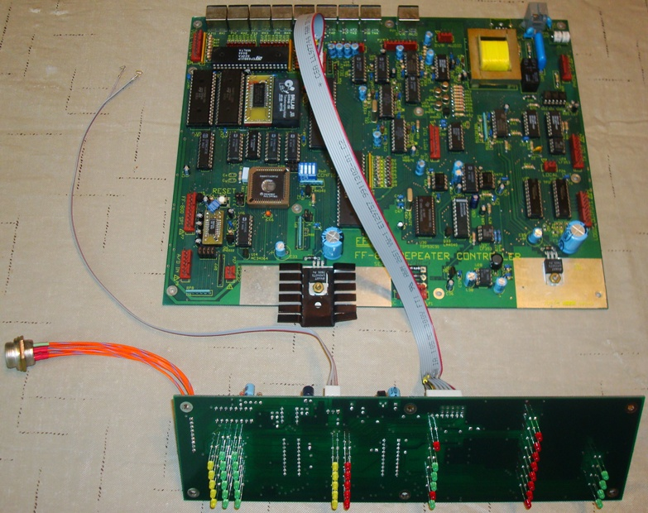

Photo 1. Mockup of the FF-8010 and an FF-800 showing the approximate locations of the circuit cards and cables.

OPERATION OVERVIEW

The FF-800 manual describes the operation of the FF-8010 display. The display control command, <cntl>490 is used to set the display mode (bright, dim, or off). The display mode is maintained in the FF-800 state, so a state save must be performed to preserve the display mode for a given state.

Note: For new installations, the FF-8010 will generally be in the OFF mode, so the installer will have to unlock the FF-800, and issue <cntl>4902 (<cntl> = “00” for the default code settings) to activate the display.

INSTALLATION

The FF-8010 installs inside the FF-180 chassis and connections are made to the FF-800 at J23 (a Molex 7-pin connector located at the rear of the FF-800). A 3-wire cable conveys the local microphone audio and PTT. These connections are at P3, which is also near the rear of the FF-800. This cable is supplied with Molex pins crimped, but not inserted into a housing. If a housing is already installed at P3, then the installer must insert the pins as shown below. If no housing is present, use the supplied 9-pin housing and insert the pins as shown below. Lastly, an 8-pin circular to 9-pin Molex cable is included to allow connection of a user-supplied microphone.

The FF-8010 is supplied with pre-wired cables for connection to the FF-800. The module is designed to install into the front of the FF-180 chassis using six (6), 4-40 x ¼” screws. To install the FF-8010, remove the FF-180 chassis cover and follow these steps:

- Locate the holes for the LED display (indicated by the silkscreen legend on the front panel). There should be six (6), 4-40 x ½” standoffs installed in a rectangular pattern surrounding the LED holes. Carefully remove the FF-8010 from the shipping frame by removing the six (6) nuts that secure the frame screws to the FF-8010. Note: The shipping frame should be retained for the warranty period in case the FF-8010 needs to be returned for service.

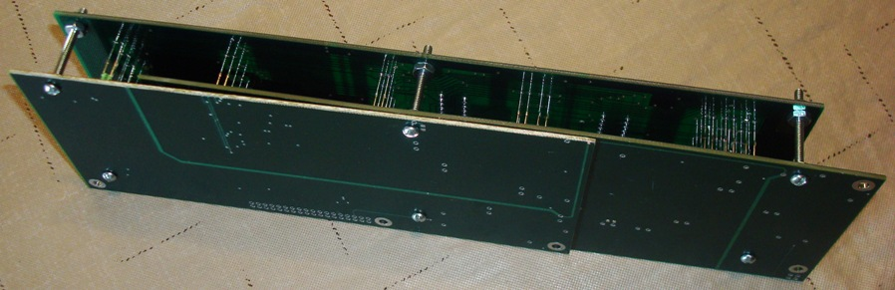

Photo 2. FF-8010 with shipping frame attached.

- Make sure that none of the LEDs were misaligned during shipping or handling (all LEDs should extend perpendicularly from the FF-8010 PCB). If any are misaligned, carefully bend the affected LED(s) so that they are straight. Carefully place the FF-8010 so that the LEDs all enter the corresponding hole in the FF-180 front panel. Depending on the FF-180 lot and MFG tolerances, the LEDs may or may not protrude from the surface of the front panel. Secure the FF-8010 with six (6) 4-40 x ¼” truss-head screws (provided).
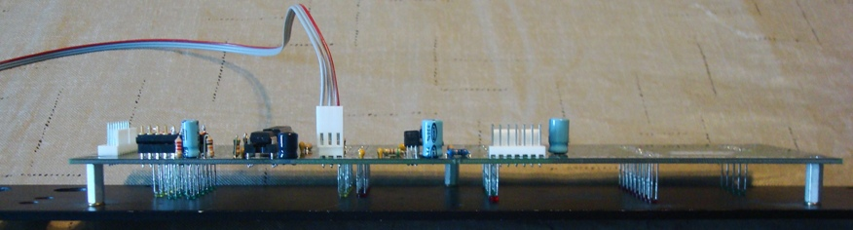

Photo 3. Mockup view of FF-8010 installation (Note: when installed in the FF-180 chassis, the chassis base will be between the FF-8010 and the front panel).

- Attach the FF-8010 data/power cable (7-pin Molex on both ends) from P101 on the FF-8010 to P23 on the FF-800. The cable pinout is identical on both ends, so the orientation is not critical.
- Locate P3 on the FF-800. If there is a Molex housing installed, use this housing to insert the pre-crimped pins from the 3-wire cable as shown in the table below (if pin 9 of P3 is already occupied, the installer may either tape and secure the FF-8010 ground pin, or may cut and secure the ground lead). Otherwise, use the provided 9-pin Molex housing to secure the pins. The other end of this cable installs at P103 of the FF-8010.

Signal Description | FF-8010 * | Destination | Color Code
Microphone Audio | P103-1 | FF-800: P3-2 | Red
Microphone PTT | P103-3 | FF-800: P3-3 | Gray
GND | P103-2 | FF-800: P3-9 | Gray
* Pre-terminated at a 3-pin Molex housing.

- Locate the 8-pin microphone cable included with the FF-8010. Remove the nut and washer from the cable. To accomplish this, make a sharp bend of the wires at the Molex housing, and then carefully pass the nut and washer over the housing (see the photos below). Using this same technique, insert the Molex housing from the front panel into the chassis (Note: most front panel cut-outs are slightly undersized and may require filing with a round hand-file or a Dremmel mini-sanding drum to allow the 8-pin connector to seat in the mounting hole – DO NOT SAND OR FILE THE HOLE WITH THE CABLE INSERTED!). Once seated, replace the washer and nut on the cable and attach to the connector finger tight. Rotate the connector so that the alignment dimple in the connector pin cavity is oriented “UP”. Using a small pair of channel lock pliers to hold the 8-pin connector body, and a medium crescent wrench, tighten the microphone connector nut. Straighten the wires at the Molex housing and attach the Molex end of the cable to P102 on the FF-8010.

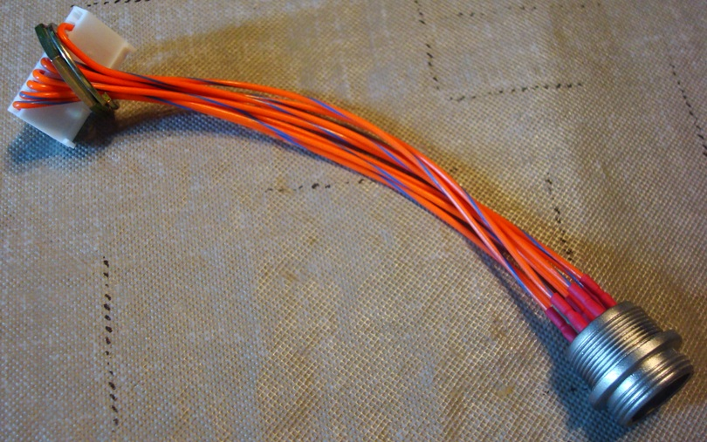

Photo 4. FF-8010 Microphone cable

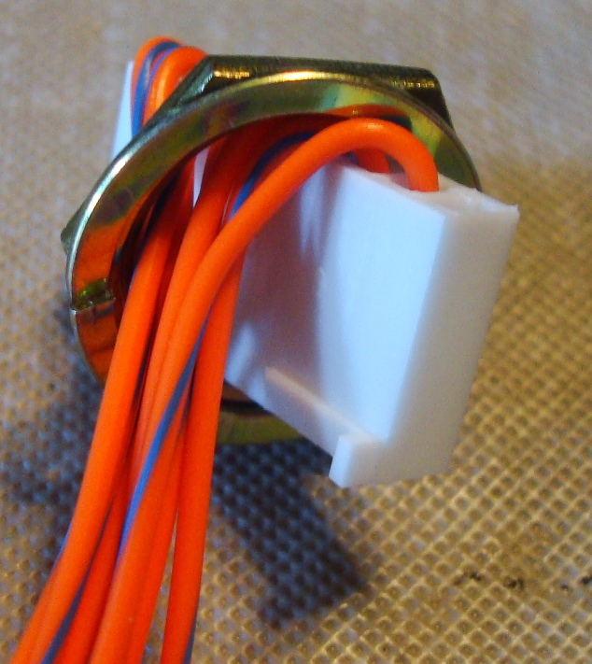

Photo 5. Close-up view of microphone cable nut removal procedure.

- The FF-8010 features a removable, 16-pin DIP header (located near P102) that is used to program the microphone wiring. If the user specified a preferred microphone type when ordering, this header will be pre-wired for that microphone. If not specified, or if the user wishes to change the microphone type later, this header will have to be re-wired to match the new microphone. See the FF-800 Technical Manual (the FF-8010 section) for instructions on how to wire this header.
- Apply power and test the FF-8010 operation. Using a DTMF command path (the local microphone should be active unless it was disabled in the FF-800 configuration), enter: 100 (default control unlock, responds “OK”) followed by 004902 (default control prefix, display control command, responds “L E D High”). The display should be active and the LEDs for the enabled ports should be illuminated. The DTMF LED should illuminate if the user enters a DTMF signal into an enabled port.
- This completes the FF-8010 installation. The installer may replace the FF-180 lid and return the FF-800 to its normal installation location.

